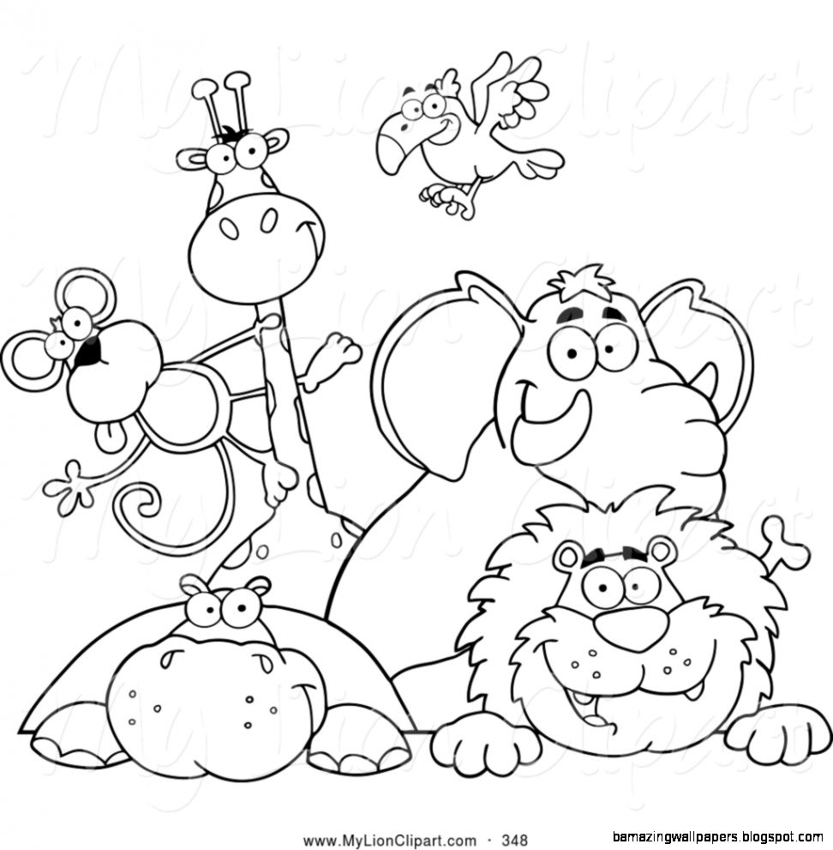

___________________’s

Animal Research Project

ANIMAL RESEARCH PROJECT

Choices: I can research an animal and create one of the following to show what I have learned.

Research Book  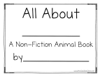 | Habitat Box  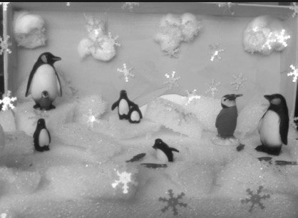
Poster  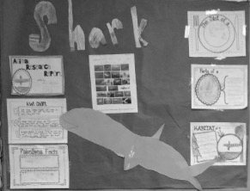 | Seesaw Video  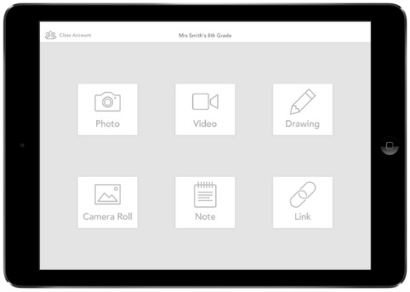

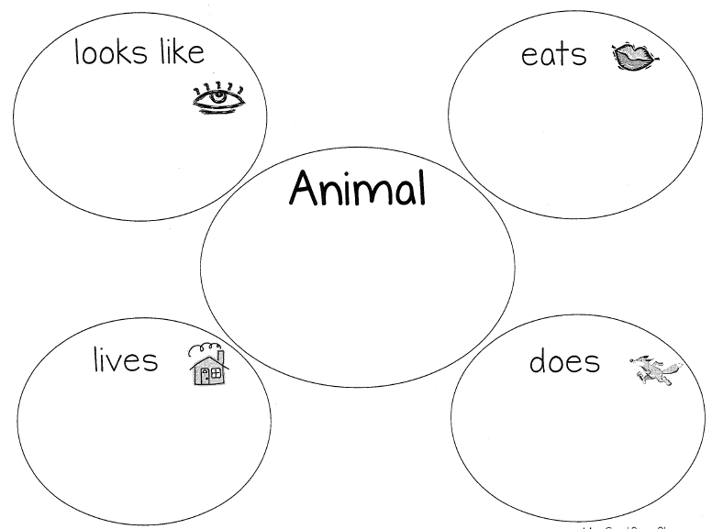

ANIMAL RESEARCH PLANNING TEMPLATE

I am going to make a ____________________________________ (circle below)

Research book Poster Habitat Box Seesaw Video

Here is what it is going to look like:

ANIMAL RESEARCH PROJECT CHECKLIST
I can complete everything below and cross it off when I am done.

Read at least 1 book on my animal | Complete research template with drawings and labels | Complete planning template  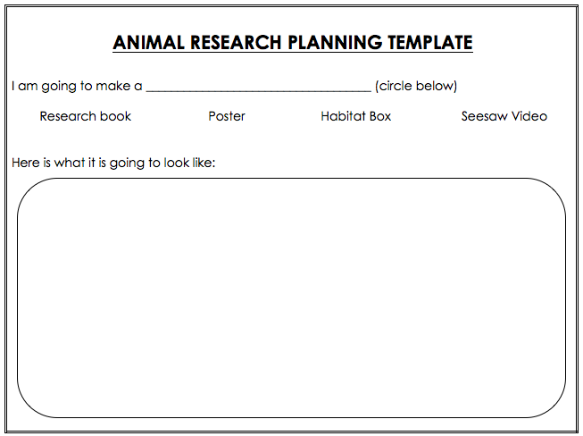
Show what my animal looks like | Show where my animal lives  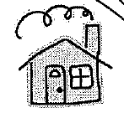 | Show what my animal eats
Show what my animal does  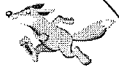 | Share 2 facts about my animal | Write labels  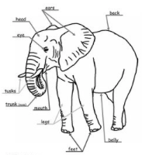

ANIMAL RESEARCH PARTNER HELP
I can help my partner do their Sunflower BEST work.
Color in the stars to show your partner if they are all done, need to add more, or are missing something from their project

= Missing from project = Need to add more = All done!

Show what my animal looks like | Show where my animal lives | Show what my animal eats
Show what my animal does | Share 2 facts about my animal | Write labels

ANIMAL RESEARCH FINAL CHECK

Did I fix or add to my project based on what my partner said?

= Missing from project = Need to add more = All done!

Show what my animal looks like | Show where my animal lives | Show what my animal eats
Show what my animal does | Share 2 facts about my animal | Write labels

Created by Ashley Grimes, Sunflower Elementary 2019

