Name: _____________________________________

Family Day Activity Board- Fairy Tales
I can choose from the activities below to do with my family. When we finish them I can cross them off.

Build a House for the 3 Little Pigs  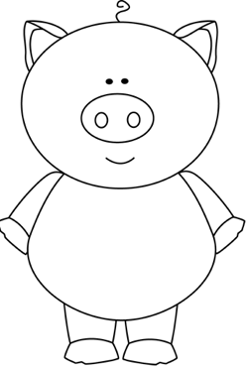 | Write your own Fairy Tale  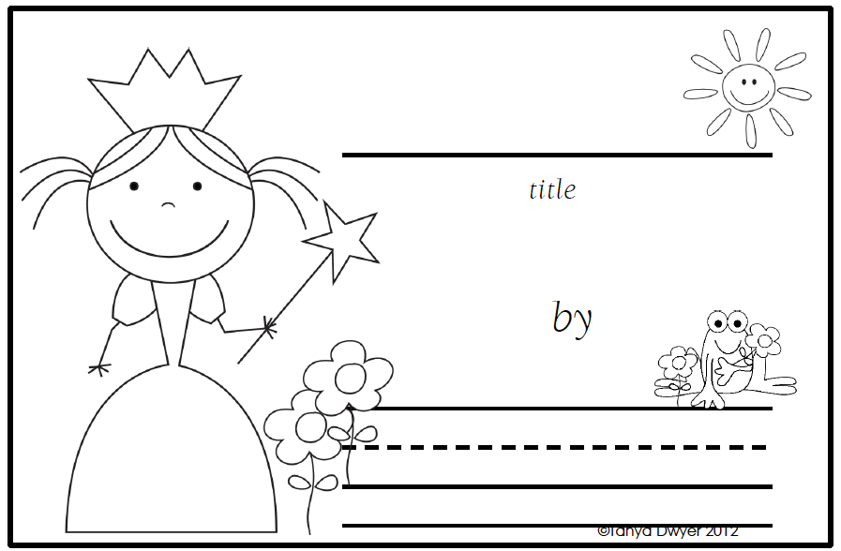 | Fairy Tale Memory Game
Rapunzel Chutes and Ladders  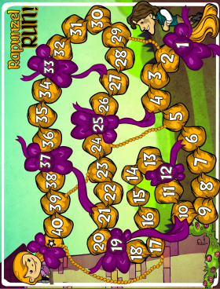 | Fairy Tale Measuring  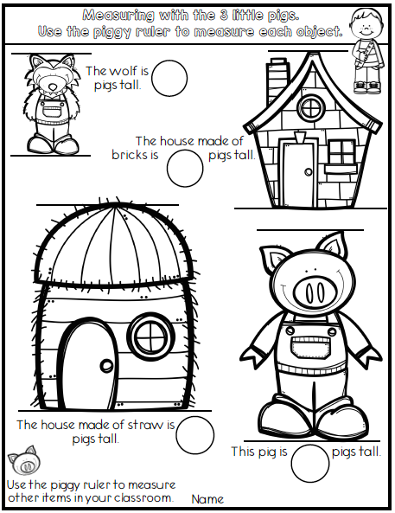 | Paint a Crown  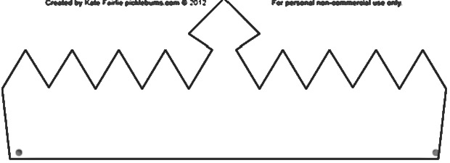
Fairy Tale Write the Room  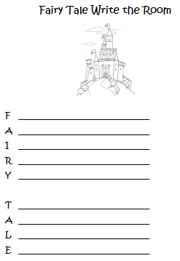 | Fairy Tale 4 in a Row  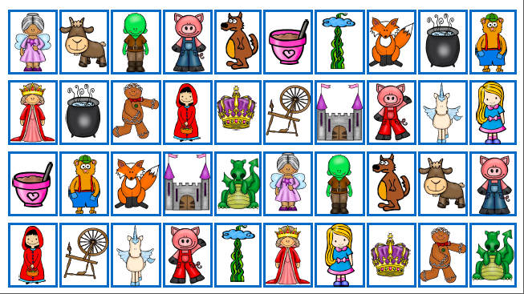 | Make a Castle for Cinderella  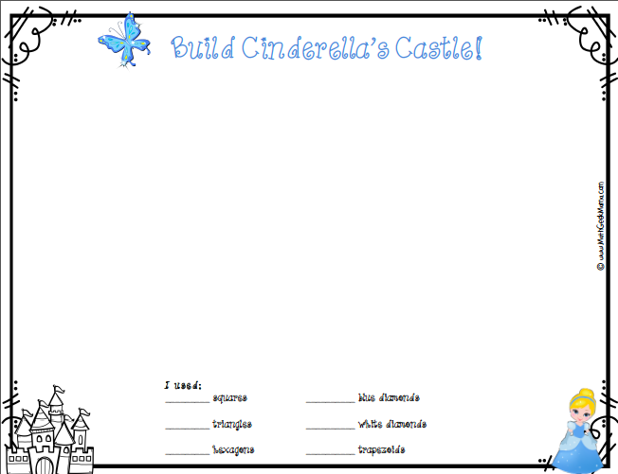
Created by Ashley Grimes, Sunflower Elementary 2019

